Thanks to Stack Overflow, annually they conduct a massive survey of developers on their site, covering many kinds of information like programming languages, salary, developer jobs and various other information.

I found the survey data containing such interesting information about:

- Want to Work with Language: The developers answer the survey question “which languages have you done extensive development work in over the past year, and which do you want to work in over the next year?”

- Have Worked with Language: The developers answer the survey question “which languages have you done extensive development work in over the past year, and which do you want to work in over the next year?”

From what I've learnt from the lessons Data Science Process and Communicating to Stake Holders I would like to apply on the 2017 Stack Overflow survey data to answer the following questions:

- What programing language was most popular?

- Who had the higher salary btw the developers with and without the most popular language? Can the most popular language helped the developers get higher salary?

From the data I got the interesting answers:

* Java is the most popular language that the developers want to work with and have also worked with.

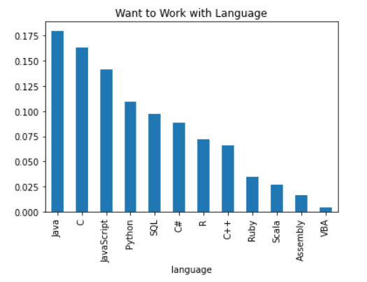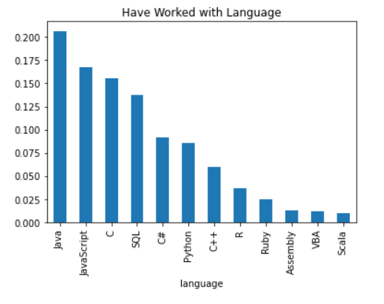

* The average salary that the developers with Java skill earn is lower than the average salary that the developers without Java skill earn: 56094.37671072892 < 60523.83649779653. And the average salary that the developers want to work with Java earn is also lower than the average salary that the developers don’t want to work with Java earn: 54,915.35810067917 < 60,388.88793015687. So it's understandable, Java is most popular language thus it cannot help the developers get higher salary. To get higher salary the developers need to master the more dedicated languages.